Pokétorial Quiz Study Guide/Review
The Basics
Pokémon is a turn-based strategy game. You play as a Pokémon trainer, a person who catches, breeds, trains, and battles pokémon against other trainers. Every Pokémon can learn up to 4 moves which it can use in battle against other pokémon. When a pokémon is defeated, your pokémon gains EXP (experience) points. When it gains enough EXP, it levels up, getting stat boosts.
Types and Matchups
So far there are 18 Pokémon types: normal, fire, water, grass, electric, fighting, flying, poison, ground, rock, psychic, ice, bug, ghost, dragon, dark, steel, and fairy. They all matchup to each other, either being normally effective, super effective (double power), not very effective (half power), or not effective (no damage). 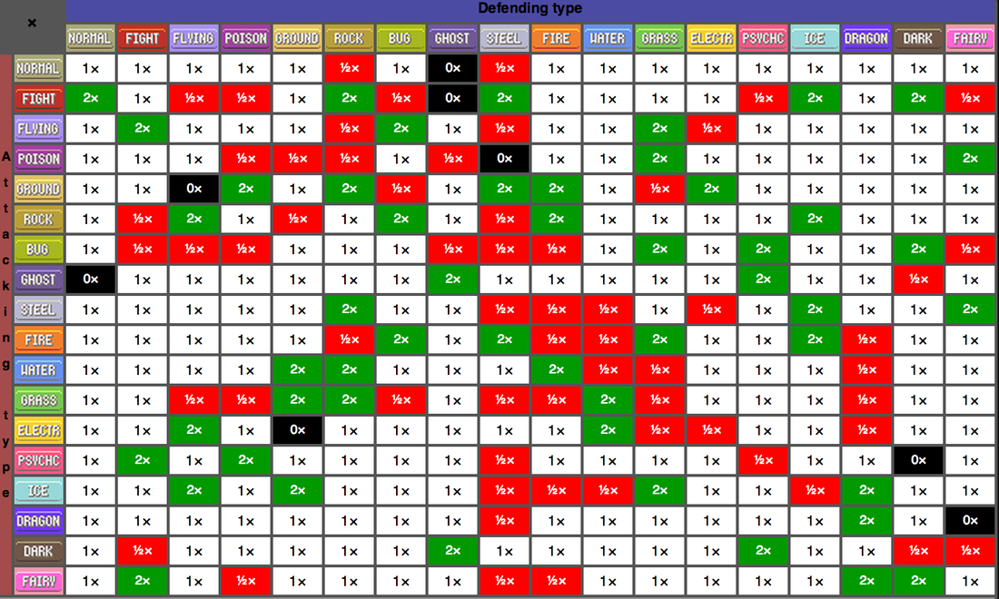
Moves, Stats, Abilities
There are six basic Stats that every Pokémon has: HP (hit points), Attack, Defense, Sp. Atk (special attack), Sp. Def (special defense), and Speed. Every time a Pokémon gains a level, it gets its stats boosted. Every Pokémon can learn four moves, which each have a type, and moves are more or less effective on certain types of Pokémon. Every move is one of three categories: Physical, Special, or Status. Attack and defense affect physical moves while special attack and special defense affect special moves. Every Pokémon can have one Ability as well. Abilities are passive effects that can do pretty much anything from raising your stats in certain conditions, making you invulnerable to certain move types, or even changing the Pokémon’s type, like Arceus’ Multitype ability. As of now there are 191 abilities.
Catching
Catching Pokémon is a term referring to acquiring wild Pokémon by catching them in a Poké ball. There are 26 different types of Poké balls:
Poke Ball: A normal Poke Ball.
Great Ball: Better than the Poke Ball.
Ultra Ball: Better than the Great Ball.
Master Ball: Ultimate Poke Ball. Never fails.
Safari Ball: Only used in the Pokemon Safari.
Level Ball: Works better on Pokemon of lower levels than your Pokemon.
Lure Ball: Works better when fishing.
Moon Ball: Works better on Pokemon that evolve with a Moon Stone.
Friend Ball: Makes the caught Pokemon friendly.
Love Ball: Works great on Pokemon the opposite gender of but same species as your Pokemon.
Heavy Ball: Works better on heavier Pokemon.
Fast Ball: Works better on fast Pokemon or Pokemon able to flee from battle.
Sport Ball: Only used in the Bug-Catching Contest.
Premier Ball: Same as Poke Ball, but rarer.
Repeat Ball: Works better on Pokemon you've already caught.
Timer Ball: Works better the longer the battle's been.
Nest Ball: Works better on lower-level Pokemon.
Net Ball: Works better on Water- and Bug-type Pokemon.
Dive Ball: Works better on Pokemon encountered underwater or while surfing or fishing.
Luxury Ball: Makes the caught Pokemon more friendly.
Heal Ball: Fully restores the caught Pokemon's HP, PP, and Status.
Quick Ball: Works better early in the battle.
Dusk Ball: Works better in caves or at night.
Cherish Ball: Same as Poke Ball. Extremely rare.
Park Ball: Only used in the Pal Park.
Dream Ball: Only used in the Entree Forest.
If a wild Pokémon has certain status conditions (frozen, asleep, paralyzed) it will be easier to catch. There is also a useful move for catching, False Swipe, which will never KO a pokémon.
Training
The first step of training Pokémon for a team is getting the right Pokémon: with the right nature and characteristic for your strategy, and for advanced trainers, a more advanced mechanic, IVs (individual values).
Natures
Lonely: Attack +, Defense -
Brave: Attack +, Speed -
Adamant: Attack +, Sp. Attack -
Naughty: Attack +, Sp. Defense -
Bold: Defense +, Attack -
Relaxed: Defense +, Speed -
Impish: Defense +, Sp. Attack -
Lax: Defense +, Sp. Defense -
Timid: Speed +, Attack -
Hasty: Speed +, Defense -
Jolly: Speed +, Sp. Attack -
Naive: Speed +, Sp. Defense -
Modest: Sp. Attack +, Attack -
Mild: Sp. Attack +, Defense -
Quiet: Sp. Attack +, Speed -
Rash: Sp. Attack +, Sp. Defense -
Calm: Sp. Defense +, Attack -
Gentle: Sp. Defense +, Defense -
Sassy: Sp. Defense +, Speed -
Careful: Sp. Defense +, Sp. Attack -
Hardy: No boost
Docile: No boost
Serious: No boost
Bashful: No boost
Quirky: No boost
Characteristics
HP: Loves to eat, Takes plenty of siestas, Nods off a lot, Scatters things often, Likes to relax
Attack: Proud of its power: Likes to thrash about, A little quick tempered, Likes to fight, Quick tempered
Defense: Sturdy body, Capable of taking hits, Highly persistent, Good endurance, Good perseverance
Special Attack: Highly curious, Mischievous, Thoroughly cunning, Often lost in thought, Very finicky
Special Defense: Strong willed, Somewhat vain, Strongly defiant, Hates to lose, Somewhat stubborn
Speed: Likes to run, Alert to sounds, Impetuous and silly, Somewhat of a clown, Quick to flee
EV (effort value) training is a technique used to perfect a Pokémon’s stats for a certain strategy. Every Pokémon battled gives a specific set of EVs which eventually raise stats.
Battling
The goal of a Pokémon battle is to make all of the opponent’s Pokémon faint (run out of HP).
Every move has a power, accuracy, and PP (power points). The power is the strength of the move. The accuracy is how often it will hit, laid out in a percent format (a move with accuracy 50 will hit 50% of the time). A move with 100 accuracy can miss if accuracy is lowered or evasiveness of the defending pokémon is raised. A move with — accuracy will always hit, unless the opponent is in a semi-invulnerable state. PP is how many times a move can be used.
There is also a roster of status conditions that can be applied to pokémon by a move, ability, or item.
Burn: A burn will damage the burned Pokemon by 1/8 of its total HP at the end of every turn. Additionally it halves the power of the Pokemon's physical moves.
Freeze: When a Pokemon is frozen it is unable to move. Pokemon have a 20% chance of thawing from a frozen status condition every turn. Damage-dealing fire-type moves will thaw the Pokemon. Pokemon cannot be frozen in sunny weather. A frozen status condition greatly raises the catch rate of wild Pokemon.
Paralysis: When a Pokemon is paralyzed it has a 25% chance of being unable to attack. Additionally, its speed is reduced by 75% (except for Pokemon with the Quick Feet ability, in which case it will raise speed by 50%). This raises catch rate.
Poison: A poisoned Pokemon will lose 1/8 of its total HP at the end of every turn. Every 4 steps taken when not in battle will cause the Pokemon to lose 1 HP.
Sleep: An asleep Pokemon is immobile and unable to use any moves other than Snore and Sleep Talk. It lasts for a duration of 1 to 6 turns.

